**Inventory Scanning Directions/Resource sheet**

* Yasmine Bencheqroun; 07/12/16

*Updating the database with excel spreadsheet*

**Intro**: The purpose of this procedure is to utilize an efficient method to keep track and update all of the Equipment Inventory items that the IBBR is responsible for in its database. If you have the role of an IT or Facilities personnel, then these directions may come in handy for you to ensure an easy experience when undergoing this process.

**Step 1**: When you first receive the spread sheet, download and save it onto your computer.

**Step 2**: *Part a)* You must format the excel sheet that is sent to us by deleting all of the unnecessary rows on the top left of the page that give us information such as “UMCP”, “2016 Physical Inventory”, “January 2016” etc (because we do not need that info).

*Part b)* Then below, without changing the name of the header, you should combine the two rows that represent the headers of the columns, so that there is only **ONE** row that is the header, not two.

Here is an example:

**ORIGINAL**: **FORMATTED**:

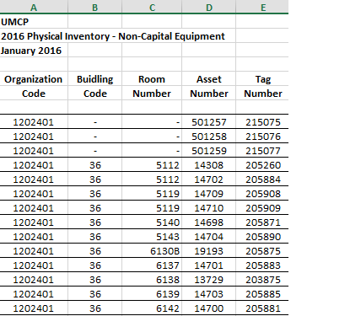 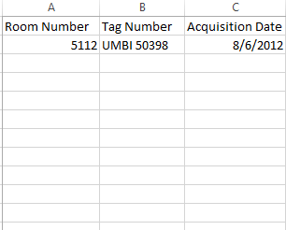

*Notice that there is nothing at the top left of the page, we deleted some columns and the headers for each remaining column are all on one row.

**Step 3**:MAKE SURE TO SAVE THE FILE AS A **CSV FILE**!!

**Step 4:** Then navigate to the webpage: [www.ibbr.umd.edu/import/Equipment_importer](http://www.ibbr.umd.edu/import/Equipment_importer) and log in.

**Step 5**: At the bottom of the page, upload the file you formatted before and click “**Import**” below.

**Step 6**: You may perform an Equipment Search under the **Facilities** tab on your dashboard to reassure yourself that it worked correctly.

*Equipment Inventory Review page*

**Intro**: This webpage was designed for Facilities or IT persons to view all of the equipment in the IBBR database that have not yet been **Time Stamped**/Visited and/or that have been **Flagged**.

**Step 1**: Log into [www.ibbr.umd.edu](http://www.ibbr.umd.edu).

**Step 2**: Navigate to the page [www.ibbr.umd.edu/equipment/review](http://www.ibbr.umd.edu/equipment/review).

**Step 3**: You may search the equipment items shown by room up to any extent in the hierarchy that you wish.

**Step 4**: You may also sort your results by ascending/descending Room, Category, Time Stamp and Flagged status (since some equipment might have not been **Flagged** but still not **Time Stamped** within the past year).

**~ Note**: A reason that an item could be **Flagged** when scanning is because the user might have encountered a reason for the item to be edited in the future.

~ **Note**: This view is designed to display items that may have not been **Time Stamped** which implies that it has not been visited in the past year.

*Inventory Scanning*

**Intro**: These steps briefly explain how to actually utilize the Barcode Inventory Scanning method at IBBR for Facilities and IT personnel only.

**Step 1**: Pair your device using the barcode scanner by first turning on the scanner and scanning the barcode that is specified in the manual to put the scanner in ‘**pairing mode**’ (it’s on page 4).

**Step 2**: Turn on **Bluetooth** on your device and wait for the ‘**General Bluetooth HID Barcode Scanner’** to pop up on the list of devices ready to be paired with. Click it. Now you are paired!

**Step 3**: On your device, navigate to the page [www.ibbr.umd.edu/inventory_scan](http://www.ibbr.umd.edu/inventory_scan)

**Step 4**: Go to the room you wish to start at and enter in the Room Selection info. You may scan all the barcodes of the items and **Confirm** or **Flag** them as you wish from here on out and you will not have to re-enter the room info as long as you are in the same room.

~ **Note**: Once you go to a new room, you must re-enter the info but it will remember it once again.

**Step 5**: If the item does not already exist in the IBBR database, you have the ability to “**Add new item**” to the database and then you will be redirected to another page to do so. Then when you’re done, you can continue going back to scanning!

*Happy Scanning! ☺*